90

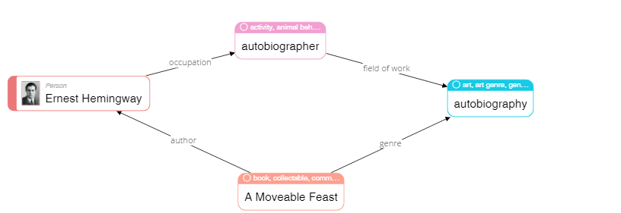

|  |
| --- |
| **Please describe shortly what you see on this diagram? Pay attention only to that information that is understandable or has sense for you.** |
| The genre of the book A moveable feast - autobiography. Author-Ernest Hemingway, who is an autobiographer, who’s been active in this case in writing autobiographies. |

68

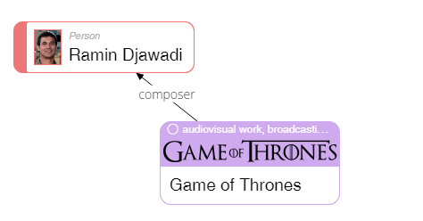

|  |
| --- |
| **Please describe shortly what you see on this diagram? Pay attention only to that information that is understandable or has sense for you.** |
| The composer of audio-video of Game of Thrones is Ramin Djawadi. He is human, not anything else, this is clearly stated by Person inscription. |

23

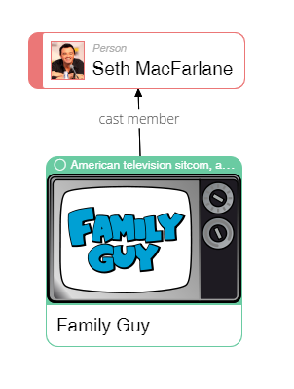

|  |
| --- |
| **Please describe shortly what you see on this diagram? Pay attention only to that information that is understandable or has sense for you.** |
| Seth MacFarlane participates in casting of american sitcom. «Family Guy». He is person. |

50

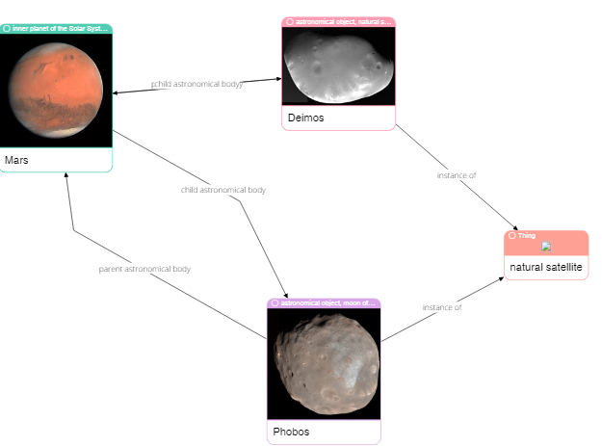

|  |
| --- |
| **Please describe shortly what you see on this diagram? Pay attention only to that information that is understandable or has sense for you.** |
| Phobos and Deimos - are natural satellite. THey are daughter astronomical bodies for Mars. Mars - is their mother astronomical mody. The links between Mars and Deimos overlap and it’s hard to read. |

62

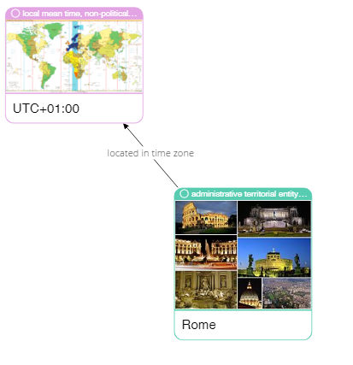

|  |
| --- |
| **Please describe shortly what you see on this diagram? Pay attention only to that information that is understandable or has sense for you.** |
| Rome is located in UTC+01 time zone. |

75

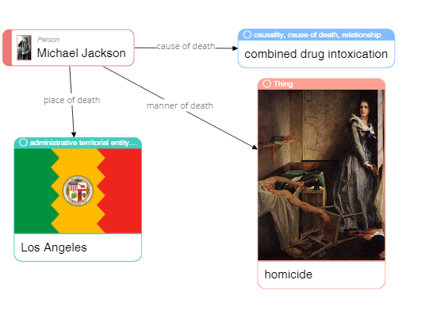

|  |
| --- |
| **Please describe shortly what you see on this diagram? Pay attention only to that information that is understandable or has sense for you.** |
| Michael Jackson is a person who died in Los Angeles, there’s its flag on the picture. The cause of death - combined drug toxication. The homicide is illustrated with an image not directly related to homicide word. |

79

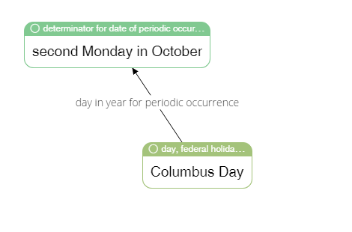

|  |
| --- |
| **Please describe shortly what you see on this diagram? Pay attention only to that information that is understandable or has sense for you.** |
| Columbus day is a federal celebration. There is an affixed day for it in a calendar, which repeats each year, second Monday of October. |

65

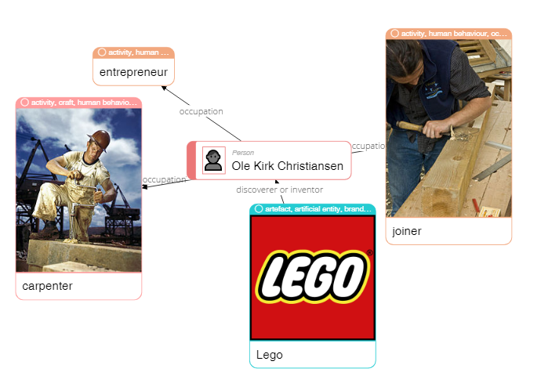

|  |
| --- |
| **Please describe shortly what you see on this diagram? Pay attention only to that information that is understandable or has sense for you.** |
| Ole Kirk Christiansen, a person, is an inventor of Lego. He also was engaged with carpeting, joining and entrepreneurship. |

4

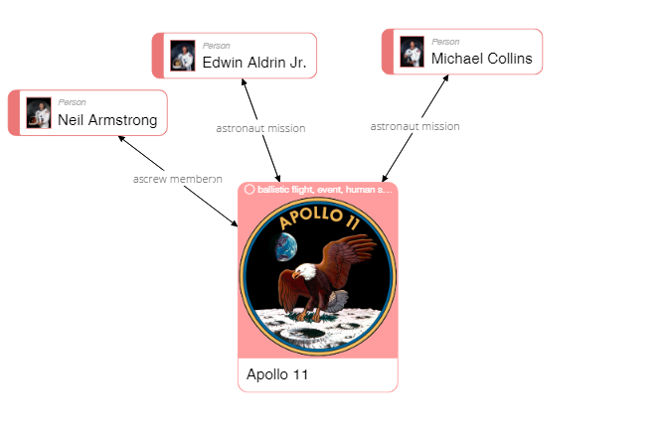

|  |
| --- |
| **Please describe shortly what you see on this diagram? Pay attention only to that information that is understandable or has sense for you.** |
| Apollo 11 - is a space mission. The astronauts of this mission are: Armstrong, Edwin Aldrin Jr. и Michael Collins. Neil Armstrong is marked as a part of the team. But two connections are overlapping making hard to read their inscriptions. It looks like incomplete information since the other two astronauts do not have a connection that states they’re team members. |

40

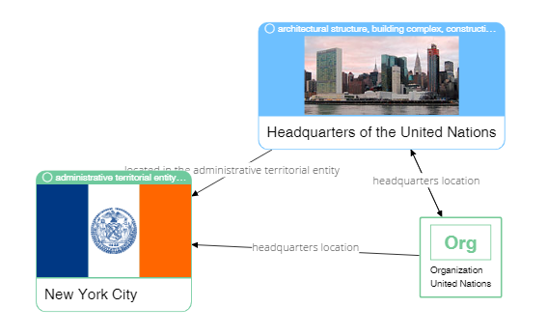

|  |
| --- |
| **Please describe shortly what you see on this diagram? Pay attention only to that information that is understandable or has sense for you.** |
| UN has ORG about it, probably, meaning organization. Its headquarters are located in New York. Some info here is redundant. |

37

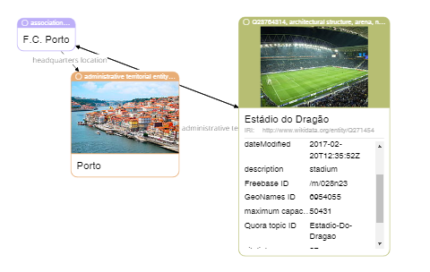

|  |
| --- |
| **Please describe shortly what you see on this diagram? Pay attention only to that information that is understandable or has sense for you.** |
| Sports arenda Estádio do Dragão is related to association FC Porto, which headquarters are located in Porto. There’s another connection on the diagram but it’s covered by pictures. |